Brachycephalic Airway Syndrome:
Does Your Pup Have Trouble Breathing?
Short-nosed dogs with “smushed” faces are definitely cute—but unfortunately, the selective breeding used to achieve that look also compromises a dog’s ability to breathe properly.
The official name for canines that are bred to have both a shortened nose and a shortened lower jaw is brachycephalic dogs. Breeds include pugs, boxers, Boston terriers, French bulldogs, English bulldogs, Pekingese and shih-tzus. If you own a brachycephalic dog or are considering getting one, it’s important you understand brachycephalic airway syndrome, which could compromise your pet’s breathing due to the following conditions:
- Stenotic Nares – These are basically closed or undersized nostrils that severely limit the dog’s ability to breathe through the nose.

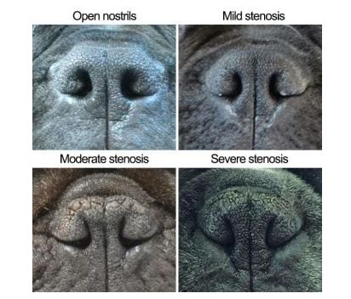

- Elongated Soft Palate –Occurs when the soft palate extends too far back into the throat and obstructs air flow to the nostrils, often resulting in a snoring or snorting sound when the dog breathes.
- Everted Laryngeal Saccules – Increased respiratory effort and negative pressures cause the natural outpouchings at the top of the windpipe to get sucked inward, further obstructing airflow.
- Macroglossa – This is an oversized, thickened tongue that takes up space in the mouth and throat, which also obstructs airflow.
- Hypoplastic Trachea –Caused by a windpipe that is undersized for the dog’s body mass.

Fortunately, surgery can correct the first three problems listed above. Our surgeons can perform those procedures at any point in your dog’s life, but we tend to recommend getting this done at the same time as spay/neuter, when the pet is young and less affected by airway compromise.

Stenotic Nares Surgery Owner Information
In brachycephalic dogs (those with a shortened nose and lower jaw), surgical intervention to increase the size of the opening of the nostrils can immensely improve airflow and your companion’s ability to breathe.
It is important you understand surgery will change how your dog’s nostrils look, because the goal of surgery is to ‘open up’ the ‘closed off’ nostril. See the below photos for examples. Guaranteed, your dog will think this is a worthwhile trade off due to the increased airflow and ability to breathe easier!
Before surgery After Surgery
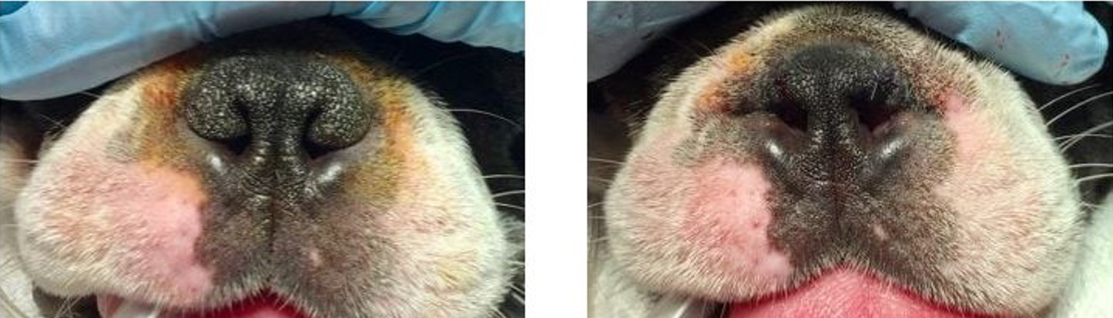
For a closer comparison, see below. The blue outline indicates the actual opening that air passes through.

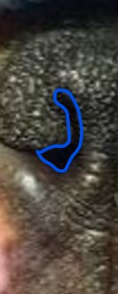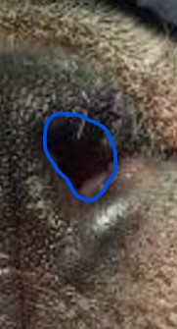
BEFORE AFTER

Have questions about brachycephalic conditions or corrective surgery? Please call us at (360) 859-0476 or send us an email at info@orchardhillsvet.com. We’re here to help!

