Before your appointment:
_______________________ has been diagnosed with diabetes. A vital part of monitoring diabetes is doing a blood sugar (or glucose) curve over several hours to determine how the body is responding to insulin. We traditionally had animals hospitalized for 8 hours and took a blood sample every 2 hours to obtain a curve. We now have the option of using
14-day Freestyle Libre System. The Freestyle Libre is part of continuous glucose monitoring system that checks reading day and night. This out-patient procedure will replace the traditional 8-hour blood sugar curve that requires hospitalization. Please read this document prior to your appointment to familiarize yourself with the system.
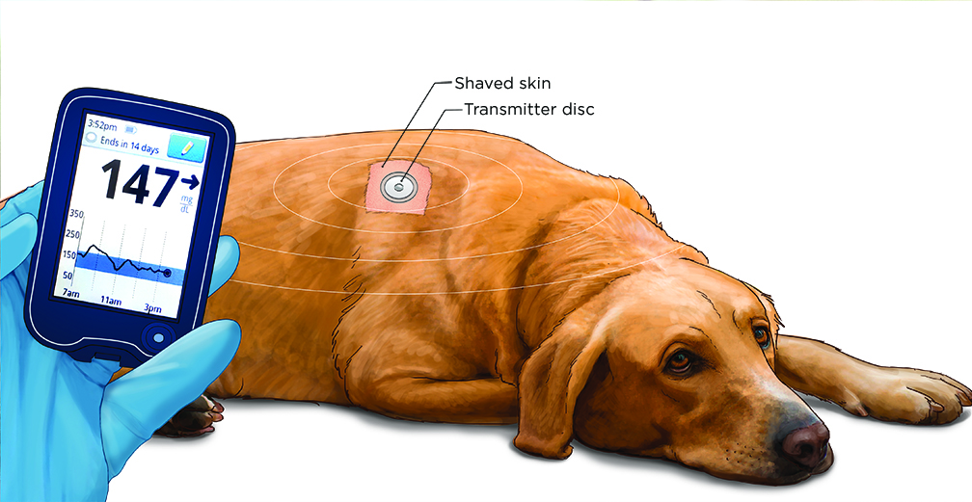

There are two components to the system: the sensor and the reader. The sensor is a 2-inch disc that placed
on the skin and has a thin filament inserted under the skin to measure glucose every minute.

There are two different ways to read the sensor. You may purchase a Freestyle Libre reader at a pharmacy,
or you can use your smart phone. There is more information about what types of phones can read the sensor below.
If you wish to use your phone, you will need to download the app, FreeStyle Libre - US for Android or Apple.
Please download app and familiarize yourself prior to your appointment. Please use the default settings.

Table 1: Recommended app, device, and operating systems for the FreeStyle LibreLink
APP/VERSION | DEVICES | OS
FreeStyle LibreLink  (version 2.2) | - iPhone 7, 7 Plus, 8, 8 Plus, X  - Samsung Galaxy S5, S6, S7, S7 Edge, S8, S8+, S9  - Google Pixel, Pixel 2, Pixel 2 XL  - Nexus 5X, 6P  - OnePlus 5T | - iOS: 11, 12, 13  - Android: 5, 6, 7, 8, 9, 10

Table 2: Not recommended device and /or operating system for the FreeStyle LibreLink
APP/VERSION | DEVICES | OS
FreeStyle LibreLink  (version 2.2) | - Samsung Galaxy S6  (SM-G920A, SM-G920V,  SM-G920T) | - Android: 9, 10

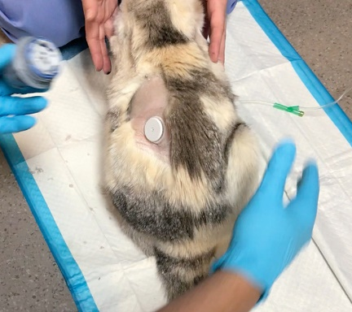
Your appointment:
Freestyle Libre can often be applied in an awake patient. The thin filament is small, and most patients do not feel the sensor
being placed. The area will be clipped and prepped to place it.
A mild sedative may be required to place the sensor.
Your doctor will discuss with you if sedation is required.
Once the sensor is placed, please scan the sensor
with your phone or reader.
It will calibrate and will take about 1 hour to get
the first sample.

After your appointment:
Most animals do not mind the sensor and will leave it alone.
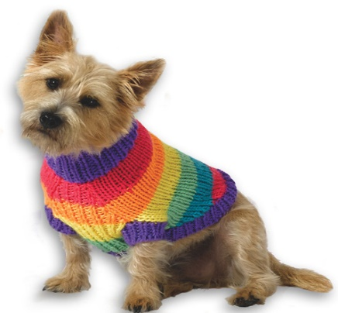
You may consider putting a sweater or t-shirt on your pet to prevent from kicking or scratching
it off. We cannot guarantee the sensor will stay on for 14 days. If the sensor comes off and
needs to be replaced, you will be charged the cost of another sensor.
We will still have enough data to monitor your pet’s diabetes even
if it only lasts 24 hours. If the sensor is still on after 14 days, we will
remove it at the recheck visit.

DURING THE MONITORING PHASE YOU WILL NEED TO DO TWO THINGS:
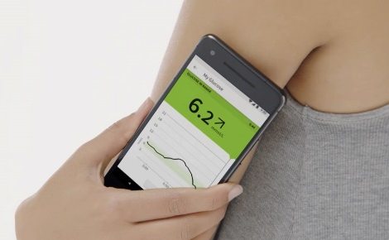
- You must scan sensor every 8 hours to obtain 24 hours of data.
You will use your phone or reader to do this.

- Please email us at info@orchardhillsvet.com every 3 days
with the curves (daily graphs).

Because our patients do not live as long as humans do, veterinarians do not have to worry about keeping blood glucose levels within the tight range required for human diabetes management. The goals of therapy, therefore, can be less rigorous, thereby alleviating some of the burden to our clients. Our goals of therapy are: the correction of clinical signs, control of concurrent diseases, and avoidance of emergency situations, such as hypoglycemia, ketosis, and hyperosmolality. Please DO NOT CHANGE DOSE WITHOUT DVM CONSULTATION. This can be life threatening and is not advised.
Please do not change insulin dose without doctor’s approval.
The doctor will only contact you throughout the two weeks if they wish to change something
or see something concerning.

HERE IS HOW TO OBTAIN DAILY GRAPHS (OR “CURVES”):
Go to left side column to find daily graph
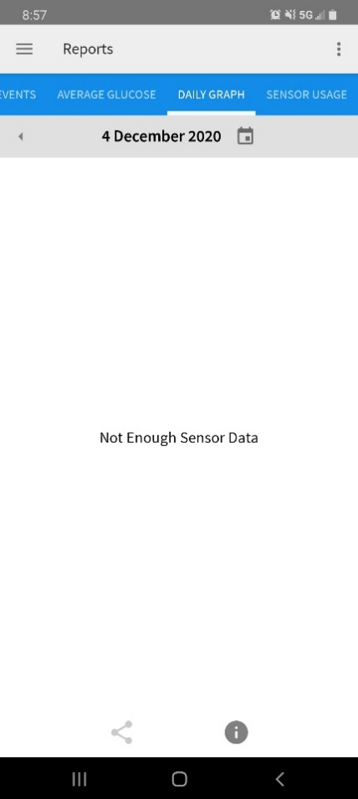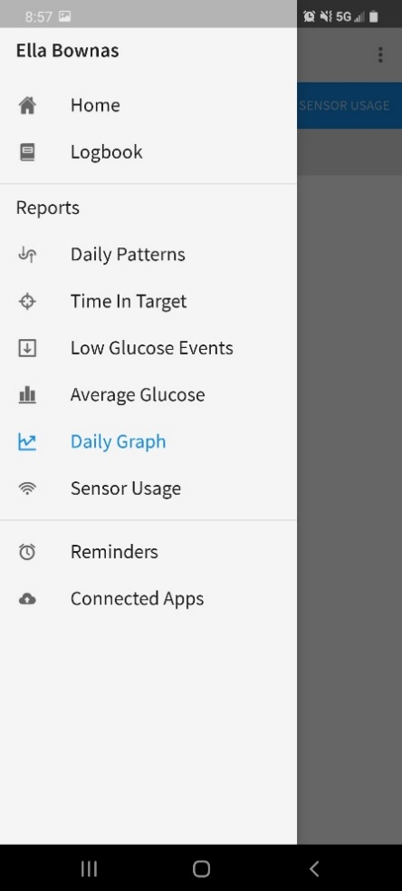

Once opening daily graph, click the share button on the bottom to email curve.

2 Week Recheck Appointment:
After 14 days, your pet will need to come back for a recheck visit to remove sensor. At this time, the doctor will
discuss results and if any adjustments are needed and when the next recheck visit will occur.

